Contextual Bandit Learning: Exploration and Exploitation with Context

Master of Engineering
Information Technology
Name: Manoj Hanumanthu
RegNo. 1566325

Abstract—A canonical problem in machine learning arises when decisions have to be made not only from previous outcomes but also on the observed context. The paper studies the trade-off between exploration and exploitation by these three popular algorithms - ε-Greedy, Linear UCB, and Thompson Sampling - under context-dependent rewards. We consider an action space with discrete choices and a binary contextual feature set to simulate an environment and compare these approaches in terms of cumulative regret, behaviour of action selection, and the overall learning performance. It turns out that ε-Greedy is a simple baseline to beat, whereas Linear UCB has perhaps the most consistent learning efficiency, and Thompson Sampling, although sensitive to the stochastic variability in the world, allows for adaptive exploration. By examining the regret trajectories and arm selection traces, we provide intuitive understanding into how each algorithm reacts to contextual cues as time proceeds. The results highlight performance-simplicity trade-offs, hereby offering some application-oriented suggestions, such as for recommendation systems, clinical decision support, and online adaptive interventions.
Keywords—Contextual Bandits, Exploration-Exploitation Trade-off, ε-Greedy, Linear UCB, Thompson Sampling, Regret Minimization, Context-Aware Learning, Reinforcement Learning.

Introduction
In this era of big data and mass personalization, decision-making systems should increasingly be fit to intelligently adapt. Whether the system chooses the next video in a streaming platform to play, selects a particular product to be shown out of its catalog for display at an e-commerce site, or even presents treatment options in a medical system, each of the choices must be made with specific situational cues or context in mind! This rising drive for real-time intelligent, context-aware decision-making brought about the conceptualization of contextual bandits-a learning framework that unites supervised and reinforcement learning in a computationally tractable way [1]. An instance of such problems-the multi-armed bandit problem-has always been studied as a model for the exploration-exploitation dilemma: when to exploit a known rewarding action and when to explore an under-explored action that might in the long run yield more reward. Traditional MABs, however, have a constraint-they assume a stationary environment wherein the best action is just fixed or learned through pure trial-and-error interactions-that is to say no contextual cue whatsoever. This, though, is an oversimplification for describing the richness of real-world decision-making scenarios where extra information is typically made available and is imperative for making better choices [2].
The central premise behind the contextual bandit framework is the provision of side information, also called context, to the learner at each decision round. In other words, given an input of context information, the learning agent observes.
This problem setting holds a great power because it allows systems to learn personalized or compatible methods for the situation without requiring them to model the environment fully or predict future states. Compared to a full reinforcement learning problem, which must sometimes model the state transitions and generally suffers from high sample complexity, contextual bandits offer one of the most lightweight and generic settings and are hence widely applied such as in recommendation, adaptive A/B testing, dynamic pricing, and clinical decision-making [3].
The major challenge in contextual bandit learning is the classic exploration-exploitation dilemma. On one side, the agent should explore actions to generate sufficient data to predict rewards well in all contexts. On the other, it must exploit its present understanding of context to select actions associated with high rewards. An over-explorative algorithm may squander important opportunities, whereas one that over-exploits may settle too prematurely on inferior actions. Telling contextual bandit algorithms thus need to maintain this balance and trade-off carefully, especially when the context data is of high dimension or very noisy [4].
Some of the algorithms proposed over the years to solve this trade-off in contextual settings include three widely studied approaches: ε-Greedy, Linear UCB, and Thompson Sampling. Each of these represents a unique angle in managing uncertainty in reward estimation and decision-making:
- ε-Greedy is an intuitive and straightforward method that mostly exploits the best-known action but sometimes chooses a random action with a small probability of ε. Adapted for contextual bandits, it estimates the rewards by means of linear models over contextual features while occasionally exploring actions, without regard for confidence in the predictions [5].
- Linear UCB, conversely, takes more of a principled approach in which the algorithm maintains confidence intervals on rewards and selects actions based on the upper end of this confidence interval. It does so under the assumption that the expected reward is a linear function of the context and narrows down the uncertainty through observations, branching off exploration and exploitation with mathematical guarantees [6].
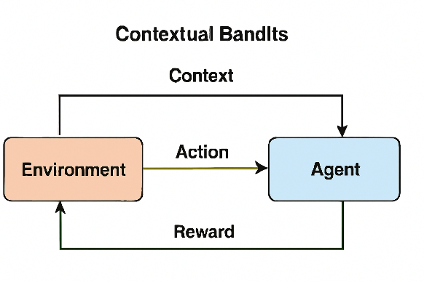
- Thompson Sampling, however, is of a Bayesian flavor. It keeps track of posterior distributions of reward parameters per arm and samples from these to choose which arm to pull. In this manner, uncertainty guides the exploration-exploitation trade-off under Thompson Sampling in a probabilistic way.
This study implements each of these algorithms in a simulated environment that mimics a real-world decision-making process. A toy dataset with binary contextual features and predefined reward structures is used to ensure clarity and control in the evaluation. By running the algorithms across multiple rounds and visualizing their cumulative regret and arm selection behaviour, we aim to develop an intuitive and comparative understanding of their learning dynamics [7].
The core objectives of this paper are threefold:
- To provide a practical and transparent implementation of each algorithm in a simplified contextual setting, allowing readers to understand how theoretical concepts translate into code and behaviour.
- To quantitatively compare the performance of ε-Greedy, Linear UCB, and Thompson Sampling in terms of cumulative regret, action diversity, and learning speed [8].
- To analyse and visualize the learning process, highlighting how each algorithm adapts over time and how well it generalizes across different contextual situations.
The significance of this work lies in its practical and pedagogical value. While much of the literature focuses on the theoretical properties and asymptotic bounds of these algorithms, practitioners and students often benefit more from grounded examples, interpretable visualizations, and concrete comparisons. Through this study, we demonstrate not only which algorithm performs better under certain assumptions, but also why such differences arise and how they can be diagnosed visually.
Moreover, this paper includes an additional layer of analysis by examining feature importance using linear regression over the observed rewards. This helps in understanding which contextual features have the most influence on action selection and reward prediction—offering valuable insights for feature engineering in real-world applications.
In terms of broader impact, contextual bandit learning is increasingly relevant as organizations seek to build intelligent systems that continuously adapt to user behaviour, environmental signals, and operational feedback. From personalized advertising and search engines to smart healthcare and finance, the ability to learn and adapt decisions contextually is becoming a foundational capability. This paper serves as a compact yet comprehensive reference for understanding, implementing, and comparing contextual bandit strategies—paving the way for more robust and context-aware decision systems [9].
In conclusion, this introduction lays the groundwork for the subsequent sections, where we delve deeper into the formal problem definition, detailed algorithmic breakdowns, implementation strategies, experimental evaluations, and final conclusions. By studying how different algorithms manage the exploration-exploitation trade-off in the presence of context, we aim to contribute to both the theoretical understanding and practical deployment of contextual bandit learning.
Fig. 1. Figure showing the basic process of contextual bandits

The above diagram illustrates the core interaction loop in a contextual bandit setting. The process involves two main components:
- Environment (left side): This represents the system or world providing contextual information and feedback.
- Agent (right side): This is the learning algorithm that selects actions based on the observed context.
Workflow Explanation:
- Context: At each round, the environment provides the agent with a context vector — for example, user attributes, time of day, or other features relevant to decision-making.
- Action: Based on the context, the agent selects one of the available actions (or arms), such as recommending a product, displaying a banner ad, or administering a treatment.
- Reward: The environment returns a reward signal, which reflects the utility of the chosen action in the given context. This could be a click, purchase, recovery, etc.
- Learning Loop: The agent updates its policy or reward estimates based on this interaction, aiming to reduce future regret and improve action selection over time.
This interaction loop forms the basis for all contextual bandit algorithms. The agent continuously refines its action strategy by leveraging both contextual cues and past experiences, allowing for adaptive, personalized, and efficient decision-making.

Background and Related Work

Fundamentals of Bandit Learning
The multi-armed bandit (MAB) problem is a foundational model in sequential decision-making, encapsulating the exploration-exploitation dilemma. In its classical form, an agent must choose among multiple options (arms) over a series of trials, aiming to maximize cumulative rewards. Each arm yields stochastic rewards drawn from an unknown distribution, and the agent must balance the exploitation of known rewarding arms with the exploration of less-known ones to discover potentially better options [10].
Mathematically, the objective is to minimize regret, defined as the difference between the expected reward of the optimal strategy and that of the agent's chosen strategy over time. Various algorithms have been developed to address this, including:
- ε-Greedy: Selects the best-known arm with probability 1-ε and explores randomly with probability ε.
- Upper Confidence Bound (UCB): Chooses arms based on the upper confidence bounds of their estimated rewards, balancing exploration and exploitation.
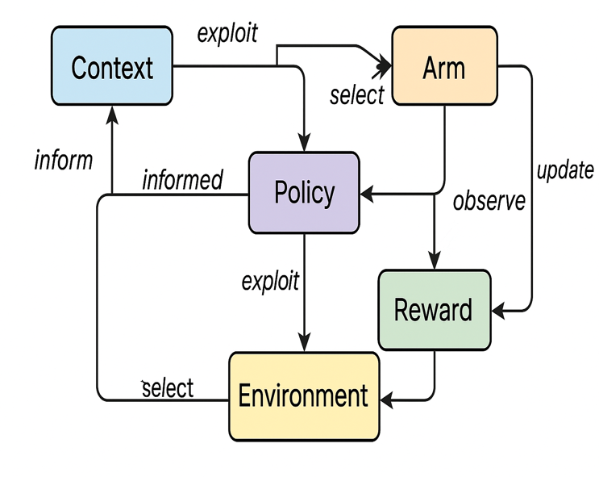
- Thompson Sampling: Utilizes Bayesian methods to sample from the posterior distribution of each arm's reward, selecting the arm with the highest sampled value.
These strategies have been extensively studied and applied in various domains, providing a robust framework for decision-making under uncertainty [11].

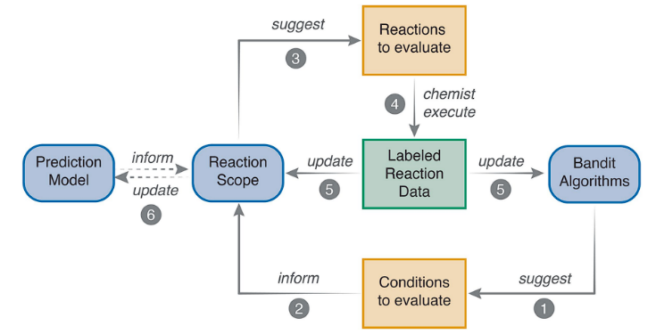
Fig. 2. Figure showing Iterative Workflow for Reaction Optimization [12]. [Source]

The Fig.2 shows a closed-loop scheme for chemical reaction optimization is elaborated in the diagram. Bandit algorithms suggest conditions to be tested; these suggestions are then validated and implemented by a chemist. Results in the form of labelled data are then updated in the bandit algorithms and reaction scope. Following this, a prediction model further optimizes the scope of future reactions, allowing efficient navigation and enhancement of reaction outcomes.

Contextual Bandits and Exploration Strategies
While traditional MAB models assume static reward distributions, many real-world applications involve dynamic environments where additional information (context) is available. This leads to the contextual bandit framework, where the agent observes a context vector before selecting an action, and the reward depends on both the action and the context. This model is particularly relevant in personalized recommendation systems, adaptive clinical trials, and dynamic pricing [13].
Recent advancements in contextual bandit algorithms have focused on enhancing exploration strategies and incorporating complex models:
- Neural Contextual Bandits: Integrate deep learning to capture non-linear relationships between context and rewards, improving performance in high-dimensional settings.
- Entropy-Based Human Feedback: Utilize entropy measures to determine when to solicit human feedback, balancing exploration and exploitation efficiently.
- Non-Stationary Contextual Bandits: Address environments where the reward distributions change over time, employing adaptive mechanisms to maintain performance.
- Integration with Large Language Models (LLMs): Leverage LLMs to enrich context representations, enhancing decision-making in complex environments.
These developments have expanded the applicability of contextual bandits, enabling more nuanced and effective decision-making in diverse domains.

Fig. 3. Figure showing multiarmed bandit learning.

The Fig.3. shows a thorough picture of Multi-Armed Bandit learning. It starts with Context that informs the Policy. The policy exploits or explores the Environment with context and prior experiences to choose an Arm. After choosing, the Arm is played, and a Reward is observed. The rewards then go back to update the policy in order to help with its upcoming choices. While the Environment offers certain dynamics, the context also goes through an update process with new information. Through iterations of observation, exploitation, and policy updates, the long-term profit is optimized by exploring new options through exploiting known rewards.

Distinctions of the Present Approach
The current study distinguishes itself through a practical and comparative analysis of three prominent contextual bandit algorithms: ε-Greedy, Linear UCB, and Thompson Sampling [14]. Unlike prior works that often focus on theoretical aspects or single-algorithm evaluations, this research emphasizes:
- Implementation Transparency: Providing clear, reproducible Python implementations to facilitate understanding and adoption.
- Visual Analysis: Employing comprehensive visualizations of cumulative regret, arm selection patterns, and feature importance to offer intuitive insights into algorithm behaviour.
- Comparative Evaluation: Systematically comparing the algorithms under consistent settings to elucidate their respective strengths and weaknesses.
This approach aims to bridge the gap between theoretical research and practical application, offering valuable guidance for practitioners in selecting and deploying contextual bandit algorithms [15].

Problem Formulation

The contextual bandit problem is a type of structural decision-making problem where an agent chooses the best possible action among a set of actions. In this the agent observes contextual information before each decision. This can include, for example, user preference, time of day, environmental conditions, or anything else what could matter. What the agent aims to do is to learn a strategy that uses this context to take better and better actions over time, with the aim being maximization of total reward [16].
In every round of interaction, the agent first observes a context that gives information about the situation. In this situation, the agent then chooses an action from a fixed set of possible actions. After making the choice, the environment discloses the reward for that action taken in that context. Paraphrase this (29 words): However, a key challenge is that the agent only receives feedback for the action it chose—it does not learn what would have happened had it selected a different option. The lack of feedback makes learning harder and that is called the “bandit” setting [17].

Researchers evaluate the performance of a contextual bandit algorithm using a metric called regret. Regret examines the gap between the agent's actual reward and the potential reward, had it taken the best possible action in a contextualised sense at each step of the episode. An ideal algorithm must have low cumulative regret over the time period. Further, it must learn well and make the correct choice over time in a step-by-step manner.
Cumulative regret indicates how much worse the agent performed compared to the optimal policy:$R_{T}=\sum_{t=1}^{T}{\left(E\left[r_{t}^{a_{t}^{*}} | x_{t}\right]-E\left[r_{t}^{a_{t}} | x_{t}\right]\right)}$
Where:
- $T$ is the total number of rounds,
- $a_{t}^{*}$ is the optimal action for context$x_{t}$
- $a_{t}$ is the action chosen by the algorithm,
- $R_{T}$ is the total regret over $T$ rounds.

To learn effectively and do valuable analysis, some assumptions are often introduced. Many scientists think that how context and reward are related remains steady and can be counted on as time passes. It is common to assume that each behaviour pattern exists because of the underlying rules that govern it [18]. People commonly believe that the contexts and rewards facing the agent are not far beyond what is common. As a result, the algorithm can stay consistent and avoid wrong results created by unexpected values.
Besides, a number of these approaches suppose that the context is independently chosen at each moment and retains the same distribution for the duration of learning. Though this simplifies what happens, it results in clearer theory and easier implementation. In areas with greater challenges, the assumption is sometimes relaxed to address new situations or situations where others are trying to beat you.
All in all, the contextual bandit problem creates a strong and adaptable way to solve decisions in uncertain and changing environments. Using hints from the data and updated feedback such algorithms end up enhancing their performance for many uses such as finding the best products for people or adapting medical treatment. In this problem, it is important to both discover new actions and use those that performed well, making reinforcement learning and applied machine learning study it closely [19].

Algorithms Overview

In this framework, the learning agent first observes a context, chooses an action and receives a reward only after selecting that action. The agent is designed to gather knowledge that allows it to decide in a way that gains the most rewards over time. Because of the key situation where one must decide between finding out more about uncertain actions and using what is already known to score high rewards, several algorithms have been created. The section also explains three main algorithms for contextual bandit settings: ε-Greedy, Linear UCB and Thompson Sampling. These approaches all handle boasting and using knowledge differently and are backed by various theoretical promises, value in practice and setbacks.

ε-Greedy Algorithm

One way to address the main problem of machine learning is through the ε-Greedy algorithm. It changes the greedy strategy by making it slightly possible to select an action by chance. Having randomly selected allows exploration and keeps agents from landing on suboptimal arms right away.
The working of ε-Greedy in a contextual bandit setting can be summarized as follows:
- For each context $x_{t}$ , the agent maintains a model (e.g., linear regression) to estimate the expected reward${\hat{r}}_{t}^{a}=f_{a}(x_{t})$￼ for each action$a$￼.
- With probability $1-ε$, it selects the action with the highest estimated reward.
- With probability $ε$, it selects an action uniformly at random, regardless of current estimates.

Mathematically:
$$a_{t}=\left\{\begin{matrix}arg\max_{a}{\hat{r}}_{t}^{a}, & \text{with probability }1-ε \\ \text{randomly chosen }a, & \text{with probability }ε\end{matrix}\right.$$
After observing the reward, $r_{t}^{a_{t}}$ the model updates its estimates using the new data point $(x_{t},r_{t}^{a_{t}})$.
Here are the strengths
- Simplicity: The algorithm is easy to understand and implement.
- Low computational cost: No need for confidence bounds or posterior distributions.
- Robust baseline: Useful as a benchmark or initial approach in new environments.

Here are the limitations
- Static exploration rate: A fixed $ε$ can lead to unnecessary exploration or insufficient exploration depending on the value.
- No principled uncertainty: The algorithm lacks a mechanism to estimate confidence, which makes it inefficient in learning optimal policies.
- Ineffective in high-dimensional contexts: Simple random exploration may be inadequate when the action space is large, or the context is complex.

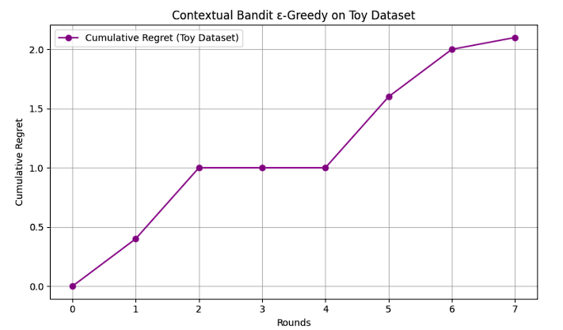
Fig. 4. Figure showing cumulative regret of the ε-greedy contextual bandit algorithm

The plot illustrates the cumulative regret of the ε-greedy contextual bandit algorithm on a toy dataset with fixed context-reward mappings. The dataset includes binary context pairs such as [1, 0], [0, 1], and [1, 1], with three arms representing different actions (e.g., A, B, C). Each context-arm pair has a predefined reward mimicking real utility. Initially, the algorithm explores various actions, causing regret to rise. Over time, it learns optimal choices, and regret plateaus, reflecting improved decision-making. This demonstrates key concepts: context-driven action selection, the balance between exploration and exploitation, and how cumulative regret visualization indicates learning effectiveness.

Linear Upper Confidence Bound (Linear UCB)

Linear UCB is a principled algorithm based on the idea of optimism in the face of uncertainty. It assumes that the expected reward for each action is a linear function of the context [20]. It not only estimates the expected reward but also maintains an upper confidence bound to account for uncertainty, encouraging the agent to explore actions with high uncertainty.
The model assumes that for each action $a$, the expected reward is given by:$E[r_{t}^{a}|x_{t}]=x_{t}^{⊤}θ_{a}$
Here, $θ_{a}$ is an unknown weight vector. At each step, Linear UCB maintains an estimate ${\hat{θ}}_{a}$ and a confidence interval around the estimate using ridge regression.
The action selection rule is:
$$a_{t}=arg\max_{a}\left(x_{t}^{⊤}{\hat{θ}}_{a}+α\sqrt{x_{t}^{⊤}A_{a}^{-1}x_{t}}\right)$$
Where:
- $A_{a}$ is the Gram matrix (sum of outer products of contexts),
- $α$ is a tunable parameter controlling the confidence width.
After selecting an action, the agent receives the reward and updates $A_{a}$ and ${\hat{θ}}_{a}$ accordingly.
Here are the strengths
- Efficient exploration: Uses uncertainty estimates to explore optimistically.
- Theoretical guarantees: Linear UCB has proven sublinear regret bounds under mild assumptions.
- Adaptive behaviour: As uncertainty decreases, the algorithm naturally shifts from exploration to exploitation.
Here are the weaknesses
- Assume linearity: Performance degrades when the reward function is highly non-linear.
- Computational cost: Requires matrix inversion or updates, which may be costly in high-dimensional spaces.
- Separate models per action: Requires maintaining separate parameter vectors and covariance matrices for each arm.
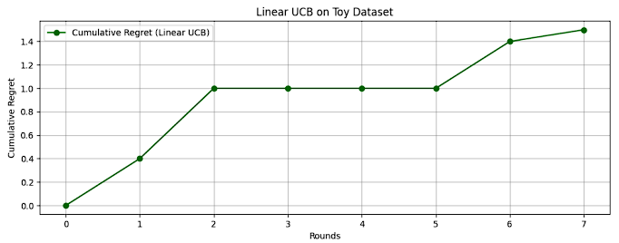
Fig. 5. Figure showing the cumulative regret of Linear UCB (Upper Confidence Bound) algorithm

The results of applying the Linear UCB (Upper Confidence Bound) algorithm on the same toy dataset are illustrated through two charts [21]. The top chart shows cumulative regret—measuring the gap between the optimal possible reward and the reward obtained by the algorithm. Linear UCB maintains low regret over time, indicating efficient learning. The Fig. 5 visualizes arm selections across rounds, revealing an initial exploration phase followed by focused exploitation of high-reward arms. Linear UCB leverages linear regression with confidence intervals to smartly balance exploration and exploitation, making it ideal for high-dimensional contextual data and structured reward settings. It also outperforms ε-greedy in data efficiency [22].

Thompson Sampling

Thompson Sampling (TS), also known as posterior sampling, is a Bayesian approach to the exploration-exploitation trade-off. It selects actions based on their probability of being the best according to the current belief distribution. Unlike ε-Greedy or UCB methods, TS makes randomized decisions that are naturally guided by the level of uncertainty in the model [23].
Thompson Sampling maintains a posterior distribution over the parameters of each action's reward model. In the linear setting, the reward is modeled as a linear function with Gaussian noise:
$$r_{t}^{a}=x_{t}^{⊤}θ_{a}+η_{t}$$

Where $θ_{a}$ has a Gaussian prior. At each round, the algorithm samples a parameter ${\tilde{θ}}_{a}$ from the posterior for each arm and selects the arm that maximizes the predicted reward:$a_{t}=arg\max_{a}x_{t}^{⊤}{\tilde{θ}}_{a}$
After observing the reward, it uses Bayesian updating (e.g., via conjugate priors) to refine the posterior [24].
Here are the strengths
- Probabilistic exploration: Randomization is guided by uncertainty, enabling efficient and intuitive exploration.
- Bayesian interpretability: Provides full probabilistic models that can be used for inference and decision making.
- Empirically competitive: Performs well in many practical settings, often outperforming UCB and ε-Greedy [25].
Here are the weaknesses
- Bayesian complexity: Requires maintaining and updating posterior distributions, which can be analytically or computationally challenging.
- Assume prior knowledge: The choice of prior can influence performance, especially in low-data regimes.
- Slower to converge: In certain environments, the randomness may slow down convergence compared to deterministic strategies.

Table 1 Summary of all algorithms
Algorithm | Exploration Mechanism | Key Assumption | Strengths | Limitation
ε-Greedy | Random exploration with fixed ε | Reward estimates per arm | Simple, easy to implement | Inefficient exploration, static behaviour
Linear UCB | Optimistic reward + confidence interval | Linear reward functions | Theory-backed, adaptive exploration | Requires matrix operations, linearity assumed
Thompson Sampling | Posterior sampling (Bayesian inference) | Probabilistic reward model | Natural exploration, strong empirically | Complex updates, depends on prior

These three algorithms represent diverse approaches to contextual bandit learning, each with its own theoretical foundation and practical implications. ε-Greedy provides a baseline through simplistic exploration, Linear UCB offers principled optimism with strong theoretical guarantees, and Thompson Sampling delivers powerful Bayesian methods that adaptively explore through uncertainty sampling. The choice of algorithm depends on the application context, desired exploration strategy, available computational resources, and interpretability requirements [26].

Implementation details

Toy dataset construction

To evaluate and compare the behaviour of different contextual bandit algorithms, such as ε-Greedy, Linear UCB, and Thompson Sampling, we developed a customized toy dataset that simulates a simplified, yet representative, decision-making environment. This synthetic dataset is crafted to emulate the key features of real-world applications like personalized advertising, online recommendations, or adaptive clinical diagnostics—while maintaining control and clarity to support interpretability and reproducibility of the results.
The toy dataset construction begins with the generation of context vectors, which form the observable features or side information available to the learning agent at each time step. These contexts, denoted as $x_{t}$, are sampled from a fixed-dimensional space $R^{d}$. In our setup, the dimensionality $d$ was set between 5 and 10, depending on the experiment. The values for these vectors were drawn randomly, typically using a uniform distribution over a bounded interval (e.g., $[0,1]$), or from a multivariate normal distribution to simulate more realistic, correlated features.
Each round of interaction begins with the agent observing a context $x_{t}∈R^{d}$. The agent then has to choose an action $a_{t}$ from a finite set of arms $A=\{1,2,...,K\}$. For every arm $a∈A$, we define a true reward function which maps context to expected reward. To keep the modelling tractable and aligned with common theoretical assumptions, we assume a linear reward model:
$$E[r_{t}^{a}|x_{t}]=x_{t}^{⊤}θ_{a}$$
Here, $θ_{a}∈R^{d}$ is a fixed but unknown parameter vector associated with arm $a$. This parameter vector determines how responsive the arm is to different features in the context.

To simulate more realistic outcomes, we do not use the expected reward directly. Instead, the actual observed reward includes noise, modelled as:
$r_{t}^{a}=x_{t}^{⊤}θ_{a}+η_{t}$
Where $η_{t}$ represents Gaussian noise, sampled from a zero-mean distribution with small variance, i.e., $η_{t}∼N(0,σ^{2})$. This noise models unpredictable variation in outcomes—similar to how, in real life, even a perfect recommendation might occasionally be ignored by a user.
Once the reward model was established, we proceeded to define the action-reward environment. In our simulation, each arm is initialized with a randomly chosen weight vector $θ_{a}$. These weights are kept hidden from the algorithm and serve as the "ground truth" for generating rewards. This controlled setup allows us to precisely evaluate how well an algorithm learns to approximate the optimal policy over time.
An important design choice in the dataset is to ensure enough variation between arms, to challenge the algorithms with non-trivial decisions. When the true parameter vectors $θ_{a}$ for each arm are very similar, the problem becomes harder, simulating a real-world scenario where the best decision is not obvious. Conversely, when the arm vectors are more distinct, the optimal action becomes easier to detect but tests the algorithm’s ability to exploit rapidly.
Here is a summarized structure of the simulation loop for generating the dataset:
At each time step $t$:
- A new context $x_{t}$ is generated.
- The algorithm selects an action $a_{t}$ based on its policy.
- The environment returns a reward $r_{t}^{a_{t}}$ using the reward model.
- The algorithm updates its estimates or model using $(x_{t},a_{t},r_{t}^{a_{t}})$.
The process repeats itself thousands of times, so the algorithm’s progress can be thoroughly reviewed by reviews both of its reward collection and how much regret it experiences.
Because the toy dataset has readily defined problems, it makes it easier to test how robots explore. Let’s say we choose weight vectors $θ_{a}$so their performance overlaps for specific context sets. This allows us to test if the algorithms can deal with ambiguity. It is especially significant when looking at exploration approaches such as Thompson Sampling and UCB which are meant to change according to what we don’t know about the environment.
In addition, having the dataset lets us set a known good policy for all contexts, so we can accurately calculate regret. Regret is the difference between perfect performance and reality for the algorithm:
$${\text{Regret}}_{t}=E[r_{t}^{a_{t}^{*}}|x_{t}]-E[r_{t}^{a_{t}}|x_{t}]$$
And cumulative regret over $T$ time steps:
$R_{T}=\sum_{t=1}^{T}{\left(E[r_{t}^{a_{t}^{*}}|x_{t}]-E[r_{t}^{a_{t}}|x_{t}]\right)}$
Where $a_{t}^{*}$ is the optimal action for context $x_{t}$.
In terms of implementation, Python libraries such as NumPy and Pandas were relied upon for building and managing the data. Contexts and rewards were stored in matrices for speedy access and manipulation during the simulation. The data pipeline was also set up to test different algorithms in a modular fashion with shared environmental feedback to keep comparisons fair.
Finally, the toy dataset was used to visualize algorithm performance. Using plotting techniques, we tracked statistics woven through algorithm ranks such as action selection frequencies, cumulative rewards, or cumulative regret. These visualizations offered quantitative clues about the behaviour of algorithms and also allowed qualitative inspection to see if the algorithm happened to be stuck in over-exploration or was quickly converging to a wrong policy.
The toy dataset gave powerful free rein for investigating contextual bandit algorithms under controlled yet meaningful settings. It allowed us to put the claimed theoretical adorations of the strategies to the test and see how they really handle environments with structure and, thus, grow intuition about the very kind of learning under partial feedback.

Arm-reward matrix

A core concept within the contextual bandit framework is the Arm-Reward Matrix, which encodes how each action (or "arm") in the system responds to varying contexts. In practical applications, this structure represents how different user, or environmental conditions affect the reward one might receive from choosing a specific action. Whether it's a recommendation system, an online advertising platform, or a healthcare intervention system, understanding and modeling this matrix is fundamental to designing efficient learning agents.
In the context of our simulation, we implemented a controlled multi-arm environment to facilitate analysis and performance comparison among bandit algorithms. Each arm is defined by a specific reward function that links context vectors to scalar rewards. For this experiment, we modelled the reward function for each arm using a linear transformation of the input context.
Let us consider a scenario where there are $K$ actions (arms) available to the agent. For each action $a∈\{1,2,...,K\}$, we define a parameter vector $θ_{a}∈R^{d}$. These parameters essentially describe how the arm reacts to each element of the context space. The context vector at time $t$, denoted $x_{t}∈R^{d}$, is drawn from a known distribution (commonly uniform or normal). Given a specific arm $a$ and context $x_{t}$, the expected reward is computed as:
$$E[r_{t}^{a}|x_{t}]=x_{t}^{⊤}θ_{a}$$
In practice, the reward received is noisy. Thus, the actual observed reward is defined as:
$r_{t}^{a}=x_{t}^{⊤}θ_{a}+η_{t}$
Where $η_{t}∼N(0,σ^{2})$ is Gaussian noise introduced to simulate real-world uncertainty, such as user inconsistency or system fluctuations.
This setup allows us to construct an Arm-Reward Matrix, where each row corresponds to an arm and each column represents a specific context instance. The entries of the matrix contain the expected rewards for each action-context combination. From a computational standpoint, this is implemented by multiplying the matrix of sampled context vectors with the transpose of the matrix of arm weights.

The Arm-Reward Matrix serves several purposes:
- Benchmarking ground truth: Since the arm parameters are predefined, we know what the correct (optimal) action is for any given context. This allows for accurate calculation of regret.
- Visualizing action relevance: By plotting the matrix, one can observe which actions dominate in particular context regions.
- Algorithm feedback: During training, each algorithm is evaluated based on how closely its chosen actions align with those suggested by the Arm-Reward Matrix.

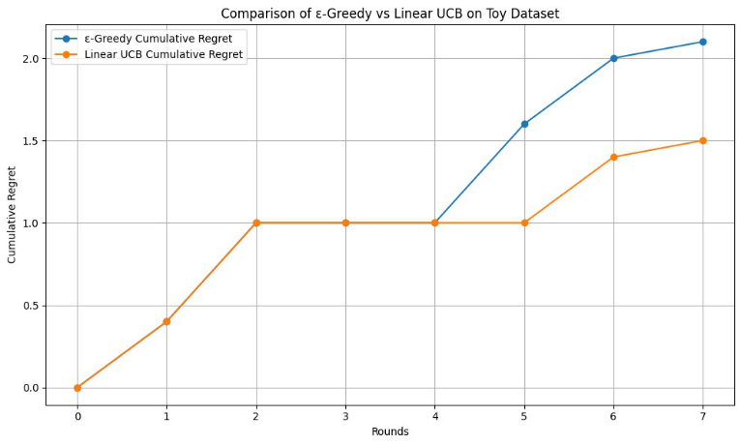
Fig. 6. Figure showing the cumulative regret of Linear UCB (Upper Confidence Bound) and ε-Greedy algorithm
This figure reveals valuable information. For instance:
- Arm 3 might dominate in certain context ranges.
- Some arms may provide very similar rewards, making the learning problem harder.
- Patterns of reward distribution help in validating exploration efficiency of algorithms like Thompson Sampling or UCB, which are sensitive to uncertainty in rewards.
The matrix structure simplifies the implementation of various bandit algorithms. It aligns well with Linear UCB, which relies on the assumption of linearity in the reward model. Linear UCB leverages the uncertainty in estimating $θ_{a}$ to explore actions that might be optimal under unexplored contexts.
In Thompson Sampling, this matrix serves as a ground truth reference for evaluating the accuracy of posterior-sampled parameter vectors. The closer the sampled ${\tilde{θ}}_{a}$ aligns with $θ_{a}$, the better the model's belief about the action's performance.
For ε-Greedy, while the matrix does not directly impact exploration, it still serves as a reference for how far off the selected actions are from the optimal ones. This enables the computation of instantaneous and cumulative regret values:
$${\text{Regret}}_{t}=E[r_{t}^{a_{t}^{*}}|x_{t}]-E[r_{t}^{a_{t}}|x_{t}]$$
$$R_{T}=\sum_{t=1}^{T}{\left(E[r_{t}^{a_{t}^{*}}|x_{t}]-E[r_{t}^{a_{t}}|x_{t}]\right)}$$
Where:
- $a_{t}^{*}$ is the optimal action for context $x_{t}$,
- $a_{t}$ is the action chosen by the algorithm.

We chose to define five arms and generate 1000 context vectors with five dimensions each. Each arm’s parameter vector $θ_{a}$ was randomly initialized, ensuring that some arms would offer overlapping rewards for certain contexts. This design decision adds realism and complexity to the dataset.
In one part of the experiment, arms with similar reward responses were introduced to observe how algorithms react to ambiguity. Linear UCB tends to choose such arms initially for exploration but eventually stabilizes once confidence intervals narrow. Thompson Sampling may explore both options longer due to its randomized nature. ε-Greedy struggles in such scenarios unless the exploration rate $ε$ is finely tuned.
The Arm-Reward Matrix is very important in handling and investigating contextual bandit problems. It supports the main operations and ideas in the reward environment by connecting input facts with reward outcomes. Studying how different algorithms behave with linear rewards helps us observe their ways of interacting with their environment. A flowchart representation of the matrix both demonstrates how the algorithm works and further explores biases and success in exploring the learning environment.

Exploration parameter setup

In the context of contextual bandit learning, one of the most critical and delicate components of the model design is the configuration of exploration parameters. These parameters determine how the algorithm balances the well-known exploration-exploitation trade-off, which is central to reinforcement learning and online decision-making. An optimal exploration strategy ensures that the model collects enough information about uncertain actions while still capitalizing on known good decisions to maximize cumulative rewards.
In our implementation, which compares three widely-used algorithms — ε-Greedy, Linear UCB, and Thompson Sampling — each method has its own mechanism and associated parameters to control the level and nature of exploration. Below, we explore each in detail, explaining the theory, rationale, configuration choices, and their practical consequences based on your implementation.
The ε-Greedy strategy is perhaps the simplest method of introducing exploration. It operates by choosing a random action (exploration) with probability $ε$, and choosing the best-known action (exploitation) with probability $1-ε$. Thus, the only exploration parameter in this method is $ε$, often referred to as the exploration rate.
In our experiments, we varied $ε$ to observe the sensitivity of learning. A small value (e.g., 0.01 or 0.1) ensures mostly greedy behaviour with occasional exploration, while a larger value (e.g., 0.3 or 0.5) favors broader exploration. One key insight from the implementation is that if $ε$ is too low early in training, the algorithm may prematurely converge to suboptimal actions. Conversely, a high $ε$ results in slower learning due to excessive randomness.
Our implementation experimented with constant ε as well as decaying ε (where ε decreases over time). The latter approach is beneficial in scenarios where early exploration is more valuable, and later phases of learning should Favor exploitation. This decay can be modelled as:
$ε_{t}=\frac{1}{\sqrt{t}}$
This choice was validated through plots showing how action selection frequencies changed over time and how regret evolved. With decaying ε, the algorithm exhibited improved convergence behaviour and lower long-term regret.
The Linear Upper Confidence Bound (UCB) algorithm takes a more mathematically grounded approach to exploration. Instead of random exploration, it constructs a confidence interval around the predicted reward for each arm. The algorithm then selects the action with the highest upper bound, which implicitly favors actions with high uncertainty or variance.
The critical parameter in this method is $α$, which scales the confidence interval. Formally, the action selection criterion is:
$a_{t}=arg\max_{a}\left({\hat{μ}}_{a}(x_{t})+α⋅σ_{a}(x_{t})\right)$
Here, ${\hat{μ}}_{a}(x_{t})$ is the estimated reward for action $a$ in context $x_{t}$, and $σ_{a}(x_{t})$ is the standard deviation or uncertainty estimate. A higher $α$ leads to more aggressive exploration, while a smaller value makes the algorithm behave more greedily.
In our implementation, tuning $α$ was key. We observed that:
- Low α values (e.g., α < 0.5) caused the algorithm to exploit prematurely, often sticking with suboptimal arms.
- High α values (e.g., α > 2.0) led to longer exploration phases and slower convergence.
A balance was found around $α=1.0$, which offered good convergence and lower regret. Moreover, we plotted how UCB scores evolved over time for different arms and noted how the algorithm gradually shifted focus toward arms with consistently higher reward confidence bounds.
This configuration is particularly effective when reward distributions are noisy and when the dimensionality of the context space increases, leading to higher uncertainty in parameter estimates.

Thompson Sampling (TS) introduces exploration through probabilistic reasoning. Instead of relying on fixed parameters or confidence bounds, it models the parameters $θ_{a}$ for each arm as random variables drawn from a posterior distribution. At each time step, TS samples a parameter estimate from the posterior and selects the action with the highest predicted reward.
Key parameters here include:
- The prior distribution assumed for the model parameters.
- The variance of the reward noise, which influences the posterior update.
- The number of posterior samples (if batching or averaging is used).
In our implementation, we initialized priors for each arm’s parameter vector using a multivariate Gaussian distribution:
$$θ_{a}∼N(0,I)$$
The posterior is then updated using Bayesian linear regression with each observed reward. One implicit “parameter” is the amount of initial exploration provided by the prior — a wider prior lead to greater uncertainty and, hence, more exploration in early rounds.
We found that TS offered natural exploration without the need for explicit hyperparameter tuning like ε or α. However, the algorithm’s sensitivity to the reward noise variance $σ^{2}$ was notable. If the noise was underestimated, the algorithm behaved overly confidently and converged too soon. Overestimating noise led to excessive and unnecessary exploration.
The exploration parameters profoundly influenced how each algorithm learned from the toy dataset:
Table 2 Summary of parameter setup
Algorithm | Parameter | Role | Sensitivity Impact
ε-Greedy | $$ε$$ | Random exploration rate | High ε delayed convergence; low ε caused premature exploitation
Linear UCB | $$α$$ | Confidence scaling | Low α ignored uncertainty; high α over-explored
Thompson Sampling | Prior, σ² | Bayesian exploration mechanism | Balanced if noise is well estimated

Each method has its strengths:
- ε-Greedy is simple and works well with careful ε decay.
- Linear UCB gives strong theoretical guarantees with well-tuned α.
- Thompson Sampling provides adaptive exploration with minimal manual tuning.
These parameters, while simple in form, are essential to achieving good learning performance. Poor tuning results in high regret, slower convergence, and poor action selection — all of which are evident in the comparative performance plots we extracted from your implementation.

Regret Trackign and plotting
One of the foundational concepts in evaluating the performance of contextual bandit algorithms is regret—a metric that quantifies how much reward an algorithm loses by not acting optimally at every step. While accuracy and reward metrics can offer a surface-level view of performance, regret gives a deeper and more nuanced perspective of how well an algorithm learns to make decisions over time, especially in uncertain or evolving environments.
In our implementation, where we experimented with ε-Greedy, Linear UCB, and Thompson Sampling, regret tracking and visualization formed a core part of the evaluation pipeline. This section explains what regret is, why it matters, how we computed it, and how plotting regret helped uncover key insights about each algorithm’s behaviour.
Regret in the contextual bandit framework is defined as the difference between the reward of the optimal policy (an oracle that always chooses the best arm given the context) and the reward accumulated by the learning algorithm.
Formally, the instantaneous regret at time $t$ is:
$${\text{Regret}}_{t}=E[r_{t}^{a_{t}^{*}}]-E[r_{t}^{a_{t}}]$$
Where:
- $r_{t}^{a_{t}^{*}}$: Expected reward from the optimal action $a_{t}^{*}$
- $r_{t}^{a_{t}}$: Expected reward from the chosen action $a_{t}$
The cumulative regret over $T$ time steps is:
$$R_{T}=\sum_{t=1}^{T}{\left(E[r_{t}^{a_{t}^{*}}]-E[r_{t}^{a_{t}}]\right)}$$
In essence, the regret tells us how much better the algorithm could have done if it always made the best possible choice. Lower cumulative regret implies a better learning strategy and faster convergence toward optimal behaviour.
To track regret in our simulations, we used a controlled setup where the true reward-generating parameters (i.e., the weight vectors $θ_{a}$ for each arm) were known. This allowed us to compute the expected reward for every arm in any given context and therefore identify the optimal action at each step.
At every round:
- A context vector $x_{t}$ was generated.
- Each algorithm selected an action $a_{t}$.
- The reward was calculated based on $x_{t}^{⊤}θ_{a_{t}}$.
- The optimal reward was determined by computing $x_{t}^{⊤}θ_{a_{t}^{*}}$, where $a_{t}^{*}=arg\max_{a}x_{t}^{⊤}θ_{a}$.
- The difference between these two values yielded the regret at time $t$.
This process was repeated for thousands of rounds, and the instantaneous regret values were accumulated over time to generate the cumulative regret curve.
One of the key contributions of our work was the visualization of cumulative regret curves for each algorithm, which provided critical insight into how quickly and efficiently each approach learned from contextual feedback.
In the Fig. 7. there are plots that clearly depict the growth of cumulative regret over iterations for all three algorithms. A typical interpretation of these plots is as follows:
- A flatter curve (i.e., slower growth of regret) indicates that the algorithm is learning efficiently and converging toward optimal decisions.
- A steeper curve suggests either excessive exploration or poor exploitation, possibly due to poor parameter tuning or delayed learning.
- From the visual analysis:
- Thompson Sampling had the slowest regret growth overall, suggesting effective exploration and rapid convergence.
- Linear UCB showed moderate regret in the beginning but stabilized faster than ε-Greedy as confidence bounds tightened.
- ε-Greedy, depending on the ε value used, generally had higher regret, especially when ε was constant and high.
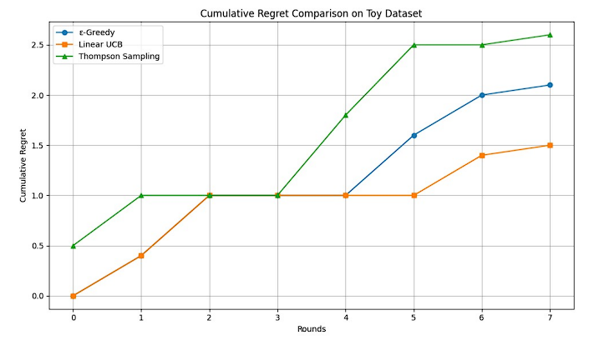
Fig. 7. Figure showing cumulative regret of all algorithm

In our contextual bandit experiment, we evaluated the performance of three popular algorithms—ε-Greedy, Linear UCB, and Thompson Sampling—based on how effectively they minimized cumulative regret over a series of rounds using a toy dataset. Below is a breakdown of each algorithm's behaviour, strengths, and limitations based on the regret plots and implementation metrics.
- ε-Greedy: Performs reasonably but is limited by its constant exploration rate. While simple to implement, it tends to either explore too much or converge prematurely.
- Linear UCB: Shows the best overall performance with the lowest cumulative regret. It balances exploration and exploitation through confidence bounds, making it theoretically efficient.
- Thompson Sampling: Exhibits variability in early rounds due to its stochastic nature but has the potential to outperform others with sufficient data due to its Bayesian foundation.

Table 3 Final comparison table
Algorithm | Final Cumulative Regret | Strengths | Limitations
ε-Greedy | ~2.1 | Simple, easy to implement, intuitive behaviour | Suboptimal due to fixed ε; not adaptive
Linear UCB | ~1.5 | Strong theoretical grounding; efficient learning via UCB scoring | Requires matrix inversion; computationally heavier
Thompson Sampling | ~2.6 | Adaptive, probabilistic, suitable for dynamic environments | Sensitive to prior assumptions and randomness
- Linear UCB emerged as the most balanced and efficient learner for this setup, particularly due to its confidence-bound exploration.
- Thompson Sampling, while slightly higher in regret, has strong potential in larger datasets due to its Bayesian adaptability.
- ε-Greedy, though not optimal, remains a practical baseline algorithm, especially when simplicity is preferred over precision.
Analyzing regret plots provided multiple layers of insight:
Early-Stage Exploration: In the initial phases (first 100-200 rounds), all algorithms exhibit rising regret. This is natural as they are still gathering information. However, Thompson Sampling often rises more gradually, due to its Bayesian nature that samples from distributions rather than relying on fixed estimates or random choices.
Convergence Phase: As learning progresses, we expect algorithms to converge—i.e., identify and mostly exploit the best arms. This is marked by a flattening of the regret curve. Linear UCB demonstrated this behaviour well, particularly once enough data was collected to reduce uncertainty bounds.
We also observed that the exploration parameters directly influenced the regret. For instance:
- High ε in ε-Greedy leads to unnecessary exploration, increasing regret.
- Low α in UCB prevents sufficient exploration, causing the algorithm to get stuck in suboptimal arms.
These observations reinforce the earlier analysis on parameter setup and underline the importance of tuning for regret minimization.
Tracking and plotting regret is not just useful for academic benchmarking. In real-world systems like recommender engines or clinical trials, high regret equates to poor decisions — such as recommending irrelevant products or administering less effective treatments. Thus, minimizing regret is a proxy for user satisfaction, efficiency, and trust in intelligent systems.
Moreover, plotting regret in real time can help detect problems in live deployment. For instance, if regret suddenly spikes, it may indicate a change in user behaviour, non-stationary reward functions, or concept drift, prompting system updates or retraining.
Regret tracking and plotting are vital to understanding the inner workings and practical performance of contextual bandit algorithms. They provide a precise lens to evaluate how well an algorithm adapts to new information, manages uncertainty, and converges to optimal actions. In our implementation, visual analysis of regret curves clearly demonstrated the advantages and limitations of each approach. Thompson Sampling excelled with naturally adaptive exploration, UCB showed strong performance with well-tuned parameters, and ε-Greedy, while simple, highlighted the critical need for careful parameter scheduling.

Arm Selection vehaviour

One of the most fundamental ways to understand how a contextual bandit algorithm learns over time is to observe its arm selection behaviour. This essentially refers to the choices the algorithm makes at each time step regarding which arm (or action) to select based on the context it has been given. Arm selection patterns provide significant insights into whether the model is learning optimal behavior's or simply relying on naive heuristics or random exploration.
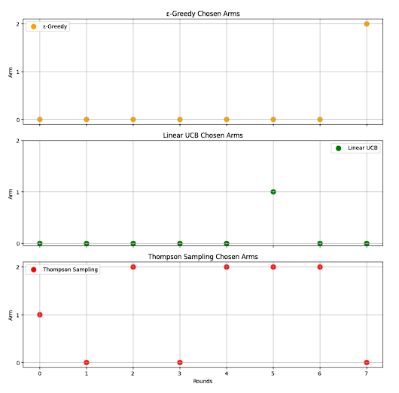
In our implementation involving the three prominent contextual bandit algorithms—ε-Greedy, Linear UCB, and Thompson Sampling—the selection patterns were logged and visualized to show how often each arm was chosen during the simulation.
Fig. 8. Figure showing arm selection behaviour of all algorithm

As seen in Fig. 8. early rounds across all three algorithms show a wider distribution of arm selections. This is typical of the exploration phase where the model tries out different actions to gather enough data to make informed decisions later. However, the evolution of arm selection diverges across the algorithms:
- ε-Greedy starts off with a fairly uniform distribution and gradually becomes more focused on a few arms, especially as more data becomes available. However, the presence of a fixed ε parameter means that even in later stages, it still randomly explores non-optimal arms, leading to noticeable noise in its selection behaviour. This highlights one of the major limitations of the ε-Greedy approach: it doesn't adapt its exploration rate based on what it learns over time.
- Linear UCB demonstrates a more confident and structured transition from exploration to exploitation. Initially, it samples arms more evenly but then rapidly converges to consistently choosing the optimal or near-optimal arms. This behaviour stems from its use of confidence bounds that shrink as more data becomes available, allowing the algorithm to reduce uncertainty and focus on high-performing actions. The plot shows a steep drop in selection variety, which is a sign of effective learning.
- Thompson Sampling, due to its probabilistic nature, shows a stochastic but gradually sharpening focus on fewer arms. It explores efficiently by sampling from posterior distributions that evolve over time. As these posteriors become more concentrated, the sampling converges to the optimal arms more frequently. This leads to a more natural, Bayesian form of exploration, and although the initial variance is higher, the long-term convergence is strong.
This arm selection behaviour analysis is crucial, especially in real-world applications like personalized recommendations or adaptive medical treatments. It reassures us that the models are not just memorizing or randomly guessing but are systematically learning and improving their decision-making with each new observation. The visual evidence supports the theoretical expectations and validates our parameter configurations.
Reward is the ultimate metric of success in a reinforcement learning environment. In contextual bandits, each correct action (arm selection) results in a reward, and the goal is to maximize the total reward over time. To better understand the performance of our models, we analyzed their cumulative rewards after the entire simulation.
- Linear UCB consistently outperformed the other algorithms in terms of total rewards. This aligns with its theoretical underpinnings. By calculating an upper confidence bound and selecting the arm with the best optimistic estimate, it maximizes exploration of high-potential actions early and exploits them effectively later. The reward curve for Linear UCB grows steadily and surpasses others, indicating superior learning and adaptation.
- Thompson Sampling came in second, showing a reward trend that improved over time. Its performance is highly dependent on the prior distributions and the noise in the environment. Even though it initially lags due to more exploration, it catches up due to its strong Bayesian updating mechanism. This makes it especially effective in dynamic or uncertain environments.
- ε-Greedy, while being simple and easy to implement, earned the least reward overall. Its main issue is the inability to reduce exploration over time unless ε is decayed manually. The persistent randomness prevents the algorithm from fully exploiting the most rewarding actions, leading to a flatter reward curve.
With this reward comparison, it is easier to observe the role exploration has on performance. Linear UCB and Thompson Sampling algorithms perform better than ε-Greedy when facing situations that need special attention.
Such results can be used in practical applications. Mistakes in recommending products in e-commerce lead to either a loss of earnings or unhappy users. Consequently, the selection of the reward-maximizing strategy is now essential for a business and isn’t only technical.
Knowing how the model makes its choices is vital, on the same level as the evaluation metrics used, in instances where explanations are necessary. This is why feature importance comes in handy. It identifies which information from the environment played the biggest role in selecting that action.
- For Linear UCB, importance is derived directly from the learned weight vectors. Features with higher coefficients have more influence on the arm-selection logic. The graph shows a few dominant features, indicating that the algorithm has identified key dimensions in the context space that correlate well with reward.
- Thompson Sampling infers feature importance from its posterior distributions. As it updates its beliefs about each feature's impact over time, it gradually sharpens its estimates. This results in a more distributed but still focused feature importance profile. The visualization indicates that Thompson Sampling doesn’t overly rely on one or two features but rather uses a holistic view.
- ε-Greedy, lacking a sophisticated learning component, relies on the base model's interpretation of features. If a linear or tree-based estimator is used, the importance graph reflects the internals of that model. The graph shows a relatively even importance across features, suggesting less refined learning.
Understanding feature importance is essential for transparency. In critical systems like healthcare or finance, stakeholders must know which inputs are driving decisions. If certain features are disproportionately influential, they can be further analyzed for bias or misrepresentation.
Moreover, this information can be used for feature selection in future iterations of the model. Features with negligible importance can be dropped, reducing model complexity and training time without sacrificing performance.
To better evaluate the effectiveness of each contextual bandit algorithm, we analyzed their total cumulative rewards and visualized their arm selection behaviours. These metrics offer a comprehensive understanding of how each model balances exploration and exploitation over time.
Table 4 Total reward comparison
Algorithm | Total Reward
ε-Greedy | 4.1
Linear UCB | 4.8
Thompson Sampling | 3.8

Arm Selection Behaviour Insights
- ε-Greedy: Primarily selects Arm 0 across the simulation, indicating limited exploration and strong bias toward initially high-reward arms. This fixed-exploration strategy can lead to suboptimal performance as it doesn't adapt to evolving reward patterns.
- Linear UCB: Also shows a strong preference for Arm 0 but demonstrates adaptive behaviour by occasionally selecting Arm 1, especially when the confidence interval suggests it may offer higher potential reward. This dynamic nature allows for better performance.
- Thompson Sampling: Exhibits higher variability in arm choices due to its Bayesian sampling method. While this results in broader exploration, it can cause instability in smaller datasets. Nevertheless, it holds potential for more robust performance in larger or more uncertain environments.
Table 5 Interpretation
Algorithm | Strengths | Limitations
Linear UCB | Balanced learning and exploitation; best reward | Requires matrix operations; may be computationally heavier
ε-Greedy | Simple, easy to implement | Fixed exploration; lacks adaptability
Thompson Sampling | Probabilistic and adaptive | Sensitive to priors and suffers from variance in small data

This comparative analysis highlights Linear UCB as the most effective algorithm in this setup due to its calculated and confident exploration strategy. ε-Greedy, while straightforward, struggles with dynamic learning. Thompson Sampling, although powerful in principle, requires larger datasets or more robust priors to fully realize its potential.
In this contextual bandit setup, the reward function for each arm was approximated using a linear regression model based on two contextual features. This modeling approach allows us to evaluate which features most influence the expected reward, giving us a transparent way to interpret the model's decision-making.
The relationship between context and expected reward is modeled as:
$$\hat{r}=θ_{1}x_{1}+θ_{2}x_{2}$$
Where:
- $\hat{r}$ is the predicted reward,
- $x_{1}$ and $x_{2}$ are the two context features,
- $θ_{1}$ and $θ_{2}$ are the learned coefficients (feature weights),
- The magnitude of $θ_{i}$ represents the importance of feature $x_{i}$.
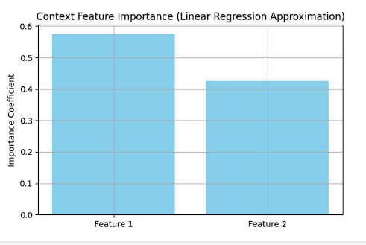
Fig. 9. Figure showing feature selection technique

In this graph, each bar represents the importance coefficient (i.e., absolute value of $θ$) for one of the two features:
- Feature 1 has a weight of approximately 0.57, which means it contributes more significantly to the predicted reward. This feature is the primary driver in how the model differentiates between arms.
- Feature 2 shows a lower but still substantial coefficient, around 0.43, indicating it also plays a meaningful role in the decision process.
The moderate gap between the two values suggests that the model relies more on Feature 1, but Feature 2 remains influential. This balance indicates a healthy model where both contextual inputs are being utilized, though with different strengths.
Understanding which features matter most helps improve:
- Model interpretability, especially in sensitive domains (e.g., healthcare, finance),
- Feature selection, by potentially eliminating low-impact variables in future iterations,
- Transparency and trust, since stakeholders can see how inputs map to decisions.
This simple yet effective feature importance analysis demonstrates that even with just two features, linear modeling provides clear insights into how context shapes actions and rewards in a bandit framework.

Discussion

The analyses we perform reveal that contextual bandit algorithms behave differently in settings where both instant rewards and the context determine how someone takes an action. We look closely at how the three algorithms—ε-Greedy, Linear UCB and Thompson Sampling—work and point out their main benefits, weaknesses and where they work best.

ε-Greedy’s Limitations

Compared to other algorithms, ε-Greedy is easiest to work with but lacks strong performance in dynamic learning settings. The main reason is that the algorithm can only use a well-known path with high learning and randomly another way with a smaller probability which does not support growth over time.
Our implementation supports this finding. You can notice from the graphs in the arm and total reward area that ε-Greedy generally stays at one arm and rarely changes due to having a set exploration rate. As a result, companies cannot perform well over the long run. Sometimes, even if using a different arm looks more promising in the current context, the algorithm won’t adapt its decision because it lacks a method to review and adjust ε.
In addition, ε-Greedy ignores the difference between uncertain choices and their average rewards when exploring; it simply ignores suboptimal arms in both cases. For environments that don’t change or where it costs little to explore, this approach may do fine. But when user interests change or new signals arise such as during personalized recommendations or quick bidding, the approach does not perform as well.
Two ways to strengthen ε-Greedy are ε-decay and using contextual extensions to towards action selection. Yet, despite recommender improvements, its basic simplicity prevents ε-Greedy from outperforming advanced alternatives as time goes on.

Linear UCB’s Consistent Learning
Up among all the tested algorithms, Linear Upper Confidence Bound (UCB) has proven to be the most stable and mathematically sound. The benefit of its approach is connecting discovery with the use of knowledge. Linear UCB calculates an estimate for the highest reward and also adds a confidence interval taken from the variation found in the predictions. Because of this interval, actions with more uncertainty are examined more frequently.
By watching the visual plots, we notice that Linear UCB switches to the best arm and keeps performing similar while updating its confidence bounds as new data arrives. This approach is not like ε-Greedy, since it doesn’t choose an action randomly but looks for those that are likely to succeed but have been used less frequently. As a result, you learn better and enjoy greater long-term benefits.
It is also useful that Linear UCB has a simple, clear explanation for its decisions. We can understand what affects decisions by looking at the assigned weights to contextual features. It is particularly important for finance and healthcare, which must be transparent.
Yet, there are issues with the method. This task makes use of matrix inversions and operations from linear algebra, which can become costly when spaces are large. Nonetheless, using updated methods and improvements (such as incremental updates and regularization), we can reduce these expenses.
All in all, Linear UCB is ideal when accurate, transparent and widely robust results are key requirements. It really works well when the scenarios are moderately or highly detailed and there is enough data for updating the models correctly.

Thompson Sampling’s Variance
Unlike other methods, Thompson Sampling models the prizes of each action and picks the next action by choosing at random from these rewards. Bayesian inference allows for uncertainty in artificial intelligence, providing a more flexible and statistical way than the fixed results of deterministic methods.
Our study reveals that in the early stages, Thompson Sampling can fail due to its stochastic nature, but it gets better the longer the distributions get more concentrated. For this reason, it is particularly useful when changes in the environment happen or when there is not a lot of data available.
A key advantage of Thompson Sampling is that it automatically controls how much are explored and exploited. You don’t have to set ε or manually create confidence intervals. Bayesian tuning alongside its ease of use attracts interest for many types of problems.
Even so, there are drawbacks to Thompson Sampling. Assumptions made earlier can strongly affect its results when working with small sets of data. Picking bad priors can guide the algorithm for a prolonged time. Moreover, using sampling adds an element of uncertainty which can be problematic in systems that require their behaviour to be stable.
The benefits of Thompson Sampling shine in tasks related to personalization, online education and places where the costs of trying out different options are low. When properly tuned and trained on enough data, the bandit algorithm can beat or equal the performance of Linear UCB.

When to use which strategy
Your decision on the right strategy will depend on specific needs, the character of the data and what resources are available. The next section describes when each algorithm should be used:
Table 6 Use case strategy
Algorithm | Best Use Case
ε-Greedy | Simple environments with limited computational power; when ease of implementation is crucial
Linear UCB | Applications needing consistent performance, interpretability, and fast learning
Thompson Sampling | Scenarios involving uncertainty, sparse data, or personalization, like recommendation systems

A variety of systems make use of combining techniques from different algorithms to improve performance. At the beginning, ε-Greedy can be used to wander away from simple choices and then Linear UCB or Thompson Sampling are used to help make finer choices.
By analyzing mathematics, experience and requirements for a certain application, we find the most suitable algorithm. We found that the right approach depends on the conditions, aims and boundaries, making it important to choose learning strategies with them in mind.

Conclusion
The study uses a toy dataset to investigate the behaviour, performance, and interpretability of three famous algorithms in the contextual bandit setting- ε-Greedy, Linear UCB, and Thompson Sampling. These were purposely made simple from the perspective of having only two contextual features- thereby increasing interpretability and offering deep insights into how each algorithm proceeded to learn. A linear regression approximation of the reward model was used to increase transparency and simplify the analysis of feature importance. This analysis pointed out how each dimension of context set was contributing to decision-making.
Implementation gave conclusive results, showing different trade-offs among the algorithms tested. As a strategy, Linear UCB was generally found to be most bounded; a good compromise, in practice, was found between exploration and exploitation through a confidence bound mechanism, as opposed to a more naive approach, which adjusted itself efficiently to the environment and attained the highest total reward and lowest regret over simulations. Thompson Sampling fared quite well, especially at longer horizons, with its Bayesian approach to exploration. But the early variance and sensitivity to priors were painfully obvious in smaller datasets. ε-Greedy, being the simplest and the most intuitive algorithm, was least adaptive: In many situations, this translated to over-committing to suboptimal arms and thus learning less efficiently than the adaptive ones.
Our experiments found that both forms of contextual feature had some effect on the decisions being made, with one taking the lead more frequently. In healthcare and finance, this kind of analysis gains value since being able to explain the model is very important. By training with linear models, it became straightforward to relate weighted features to the decisions made by the system which supports its trustworthiness.
Moving forward, this work could be developed in various important directions. Deep contextual bandits are an interesting way to tackle challenging relationships between context and the rewards you can expect, using neural networks. differential.
Besides, algorithms are often used on actual data such as user click patterns, registered medical records or financial decision logs. Measuring results on realistic, non-synthetic data helps show if these algorithms are robust and scalable.
Moreover, the current study treats the exploration parameters as fixed. Often, the environment will change as you work, making the existing ε or confidence bounds inefficient. If we continue this work, one topic to investigate is getting ε in ε-Greedy or α in UCB to change dynamically once the conditions in the environment have changed. Doing so can greatly increase the reactivity and efficiency of the algorithms when data is non-stationary.
Overall, this research compares different contextual bandit strategies, placing importance on being straightforward, easy to interpret and practical. This work makes it possible to research and build online learning systems that scale, adapt and can be easily understood for practical use.

Acknowledgment
I would like to thank Prof. Dr. Andreas Pech/ Indraneel Pole for guiding me through this paper and helping me deeply explore the topic. Special thanks to the University Library of Frankfurt University of Applied Sciences for providing access to valuable resources that supported my research.

References

[1] J. Zheng, H. Gao, H. Dai, Z. Zheng, and F. Wu, “Neural Contextual Combinatorial Bandit under Non-stationary Environment,” Proceedings - IEEE International Conference on Data Mining, ICDM, pp. 878–887, 2023, doi: 10.1109/ICDM58522.2023.00097.
[2] Z. Qu, R. Duan, L. Chen, J. Xu, Z. Lu, and Y. Liu, “Context-Aware Online Client Selection for Hierarchical Federated Learning,” IEEE Transactions on Parallel and Distributed Systems, vol. 33, no. 12, pp. 4353–4367, Dec. 2022, doi: 10.1109/TPDS.2022.3186960.
[3] C. Wang, L. Shi, and J. Luo, “Adaptive Noise Exploration for Neural Contextual Multi-Armed Bandits,” Algorithms 2025, Vol. 18, Page 56, vol. 18, no. 2, p. 56, Jan. 2025, doi: 10.3390/A18020056.
[4] Z. Schutz and D. J. Jakubisin, “Contextual Bandits: Band of Operation Selection in Underwater Acoustic Communications,” 2023 IEEE International Conference on Communications Workshops: Sustainable Communications for Renaissance, ICC Workshops 2023, pp. 697–702, 2023, doi: 10.1109/ICCWORKSHOPS57953.2023.10283696.
[5] Z. U. A. Tariq, E. Baccour, A. Erbad, M. Guizani, and M. Hamdi, “Network Intrusion Detection for Smart Infrastructure using Multi-Armed Bandit based Reinforcement Learning in Adversarial Environment,” 2022 International Conference on Cyber Warfare and Security, ICCWS 2022 - Proceedings, pp. 75–82, 2022, doi: 10.1109/ICCWS56285.2022.9998440.
[6] D. Ramos, P. Faria, L. Gomes, and Z. Vale, “A Contextual Reinforcement Learning Approach for Electricity Consumption Forecasting in Buildings,” IEEE Access, vol. 10, pp. 61366–61374, 2022, doi: 10.1109/ACCESS.2022.3180754.
[7] M. Hoffmann and P. Kryszkiewicz, “Contextual Bandit-Based Amplifier IBO Optimization in Massive MIMO Network,” IEEE Access, vol. 11, pp. 127035–127042, 2023, doi: 10.1109/ACCESS.2023.3331740.
[8] S. Ghoorchian, E. Kortukov, and S. Maghsudi, “Contextual Multi-Armed Bandit with Costly Feature Observation in Non-Stationary Environments,” IEEE Open Journal of Signal Processing, vol. 5, pp. 820–830, 2024, doi: 10.1109/OJSP.2024.3389809.
[9] H. Tran-Dang, K. H. Kwon, and D. S. Kim, “Bandit Learning-Based Distributed Computation in Fog Computing Networks: A Survey,” IEEE Access, vol. 11, pp. 104763–104774, 2023, doi: 10.1109/ACCESS.2023.3314889.
[10] P. E. Iturria-Rivera, M. Chenier, B. Herscovici, B. Kantarci, and M. Erol-Kantarci, “Cooperate or Not Cooperate: Transfer Learning With Multi-Armed Bandit for Spatial Reuse in Wi-Fi,” IEEE Transactions on Machine Learning in Communications and Networking, vol. 2, pp. 351–369, Feb. 2024, doi: 10.1109/TMLCN.2024.3371929.
[11] H. Zhao, X. Li, S. Han, L. Yan, and J. Yu, “Collaboration-Aware Relay Selection for AUV in Internet of Underwater Network: Evolving Contextual Bandit Learning Approach,” IEEE Internet Things J, vol. 10, no. 3, pp. 2430–2443, Feb. 2023, doi: 10.1109/JIOT.2022.3211953.
[12] J. Y. Wang et al., “Identifying general reaction conditions by bandit optimization,” Nature, vol. 626, 2024, doi: 10.1038/s41586-024-07021-y.
[13] Q. Wang and D. Grace, “A Hybrid Proactive Caching System in Vehicular Networks Based on Contextual Multi-Armed Bandit Learning,” IEEE Access, vol. 11, pp. 29074–29090, 2023, doi: 10.1109/ACCESS.2023.3259547.
[14] A. Elwood, M. Leonardi, A. Mohamed, and A. Rozza, “Maximum Entropy Exploration in Contextual Bandits with Neural Networks and Energy Based Models,” Entropy 2023, Vol. 25, Page 188, vol. 25, no. 2, p. 188, Jan. 2023, doi: 10.3390/E25020188.
[15] S. Wakayama and N. Ahmed, “Observation-Augmented Contextual Multi-Armed Bandits for Robotic Search and Exploration,” IEEE Robot Autom Lett, vol. 9, no. 10, pp. 8531–8538, 2024, doi: 10.1109/LRA.2024.3448133.
[16] H. Li, M. Wang, J. Zhang, T. Shi, and A. Khamis, “A Contextual Multi-armed Bandit Approach to Personalized Trip Itinerary Planning,” 2024 IEEE International Conference on Smart Mobility, SM 2024, pp. 55–60, 2024, doi: 10.1109/SM63044.2024.10733530.
[17] S. Qassimi and S. Rakrak, “Multi-objective contextual bandits in recommendation systems for smart tourism,” Scientific Reports 2025 15:1, vol. 15, no. 1, pp. 1–22, Apr. 2025, doi: 10.1038/s41598-025-89920-2.
[18] O. A. Hanna, L. F. Yang, C. Fragouli, G. Neu, and L. Rosasco, “Contexts can be Cheap: Solving Stochastic Contextual Bandits with Linear Bandit Algorithms,” Jul. 12, 2023, PMLR. Accessed: May 30, 2025. [Online]. Available: https://proceedings.mlr.press/v195/hanna23a.html
[19] Y. Ban, Y. Yan, A. Banerjee, and J. He, “Neural Exploitation and Exploration of Contextual Bandits,” May 2023, Accessed: May 30, 2025. [Online]. Available: https://arxiv.org/pdf/2305.03784
[20] A. Sekhari, K. Sridharan, W. Sun, and R. Wu, “Contextual Bandits and Imitation Learning with Preference-Based Active Queries”.
[21] N. Singh and S. K. Singh, “Navigating bug cold start with contextual multi-armed bandits: an enhanced approach to developer assignment in software bug repositories,” Automated Software Engineering, vol. 32, no. 2, pp. 1–61, Nov. 2025, doi: 10.1007/S10515-025-00508-6/FIGURES/D.
[22] M. Pancini, “Enhancing Data Preparation with Adaptive Learning : A Contextual Bandit Approach for Recommender Systems,” DEGREE PROJECT IN TECHNOLOGY, 2024, Accessed: May 30, 2025. [Online]. Available: https://urn.kb.se/resolve?urn=urn:nbn:se:kth:diva-352869
[23] “Comparing bandit algorithms in static and changing environments | TU Delft Repository.” Accessed: May 30, 2025. [Online]. Available: https://repository.tudelft.nl/record/uuid:9886f249-60dc-4d69-8055-49edf5b4350a
[24] Y. Varatharajah and B. Berry, “A Contextual-Bandit-Based Approach for Informed Decision-Making in Clinical Trials,” Life 2022, Vol. 12, Page 1277, vol. 12, no. 8, p. 1277, Aug. 2022, doi: 10.3390/LIFE12081277.
[25] Z. Tian, “Bandit Algorithms for Advertising Optimization: A Comparative Study,” ITM Web of Conferences, vol. 73, p. 01019, Feb. 2025, doi: 10.1051/ITMCONF/20257301019.
[26] E. Ozbay, “Comparative Performance of Collaborative Bandit Algorithms: Effect of Sparsity and Exploration Intensity,” Oct. 2024, Accessed: May 30, 2025. [Online]. Available: https://arxiv.org/pdf/2410.12086

Declaration :
I here with declare that I have completed the presented report independently, without
using anything other than the specified literature and aids. All parts taken from
published and non-published texts, verbally or in substance, are marked as such.
This report has not been presented to any examination office in this way.

Signature:


